2.70: The position of the cars as functions of time (taking x₁ = 0 at t = 0) are

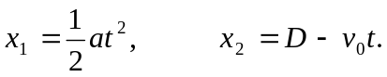

The cars collide when x₁ = x₂; setting the expressions equal yields a quadratic in t,

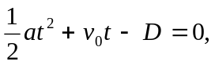

the solutions to which are

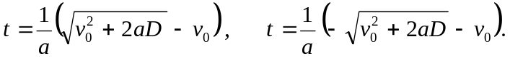

The second of these times is negative and does not represent the physical situation.

- 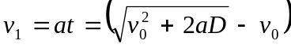

c)
